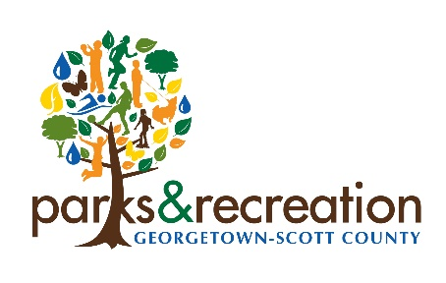
Policy: Drug-Free Workplace Adopted - Typo
Policy Number: POL.P.01.03 Page: p. 81
Originator: Kimberly Rice Date: 11/12/2020
Authorized by: ___________________ Date: _________
Board Chair
References: Policies CAPRA 1.4.1
Revision Date: _______________________

POL.P.01.05 – Drug-Free Workplace Adopted
It shall be the policy of GSC Parks that its workplace shall be drug-free in compliance with the Drug-Free Workplace Act of 1988 (PL 100-690, Title V, Subtitle D), including any future amendments. This publication provides details of this policy, a statement on dangers of drugs in the workplace, sources of information and assistance and is the basis of a form each employee is required to sign assuring compliance.

It is the policy of GSC Parks that no employee shall engage in unlawful manufacture, distribution, dispensing, possession, or use of a controlled substance in any workplace of GSC Parks. Controlled substance means a controlled substance in schedules I through V of the Controlled Substance Act (21 U.S.C. 812), and as further defined by regulation at 21 CFR 1308.11 through 1308.15, including any future additions or amendments.

The purpose of this policy is to avoid the dangers of drugs in the workplace as described further in this publication, and to advise employees of available sources of counseling, rehabilitation, and employee assistance. Each employee is hereby notified that they shall notify the Director within five (5) days of any criminal drug conviction for a violation in the workplace. Within thirty (30) days, the GSC Parks must take appropriate action.

Employees found to be abusing drugs, but not convicted of any drug statue violation, will be required to participate satisfactorily in a drug abuse assistance or rehabilitation program approved for such purposes. The employer is not required to pay for this rehabilitation. Any employee violating the terms of this policy is subject to immediate dismissal.

Policy – Purpose and Goals
Being award aware of the costs, in human terms, of the abuse of alcohol, illicit substances, and illegal drugs; and realizing the costs, both actual and potential in monetary terms, of the abuse of alcohol, illicit substances and illegal drugs in the workplace; the City of Georgetown-Scott County, Kentucky, Parks & Recreation Department (GSC Parks) is committed to protecting the safety, health and well-being of all employees of the Department and other individuals who make use of the Department’s facilities. Likewise, GSC Parks is committed to ensuring that its facilities provide a safe and healthy environment for the conduct of GSC Parks business for all the citizenry of Georgetown-Scott County, Kentucky. Additionally, GSC Parks wishes to accomplish the following with the establishment of this policy:

